1. Turing test

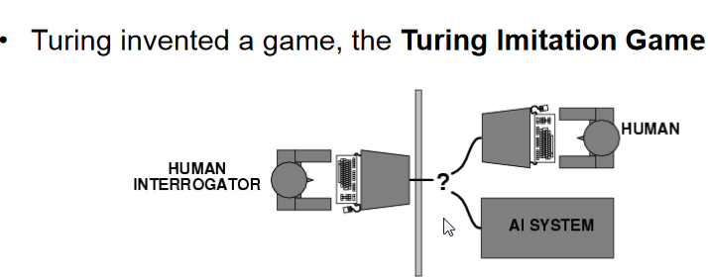

shortcoming:

This definition would be philosophical behaviorism, which has obvious problems. In short, we think that being intelligent causes the behavior, but doesn’t consist in the behavior.

This definition would define intelligence based on the subjective judgment of whomever happens to be the interrogator, however long the conversation was, and what the conversation was about.

2.PEAS

P: performance measure

E: environment

A: actuators

S: sensors

Designing an automated taxi driver:

Performance measure: Safe, fast, legal, comfortable trip, maximize profits

Environment: Roads, other traffic, pedestrians, customers

Actuators: Steering wheel, accelerator, brake, signal, horn

Sensors: Cameras, sonar, speedometer, GPS, odometer, engine sensors, keyboard

Medical diagnosis system:

Performance measure: Healthy patients, minimize costs, lawsuits

Environment: Patients, hospital, staff

Actuators: Screen display (questions, tests, diagnoses, treatments, referrals)

Sensors: Keyboard (entry of symptoms, findings, patients’ answers)

3. Expert System

purpose:

to be able to solve problems or provide advice in that domain

components:

Expert system = inference engine + knowledge base + data + explanation facilities + user interface

conventional Program = algorithm + data

3 advantages:

Natural language expression

Unified structure

Knowledge is separated from processing

3 drawbacks:

Relationships between rules are opaque

Inefficient search strategy

do not have the learning ability

4. Forward and Backward Chaining

Forward chaining: Data-driven search

starts with the facts and sees what rules to apply (and hence what should be done), given the facts.

Backward chaining: Goal-driven search

starts with something to find out and looks for rules that will help in answering it

5. Rule-Based System Architecture

A collection of rules

A collection of facts

A rule fires if a fact matches the condition of the rule